
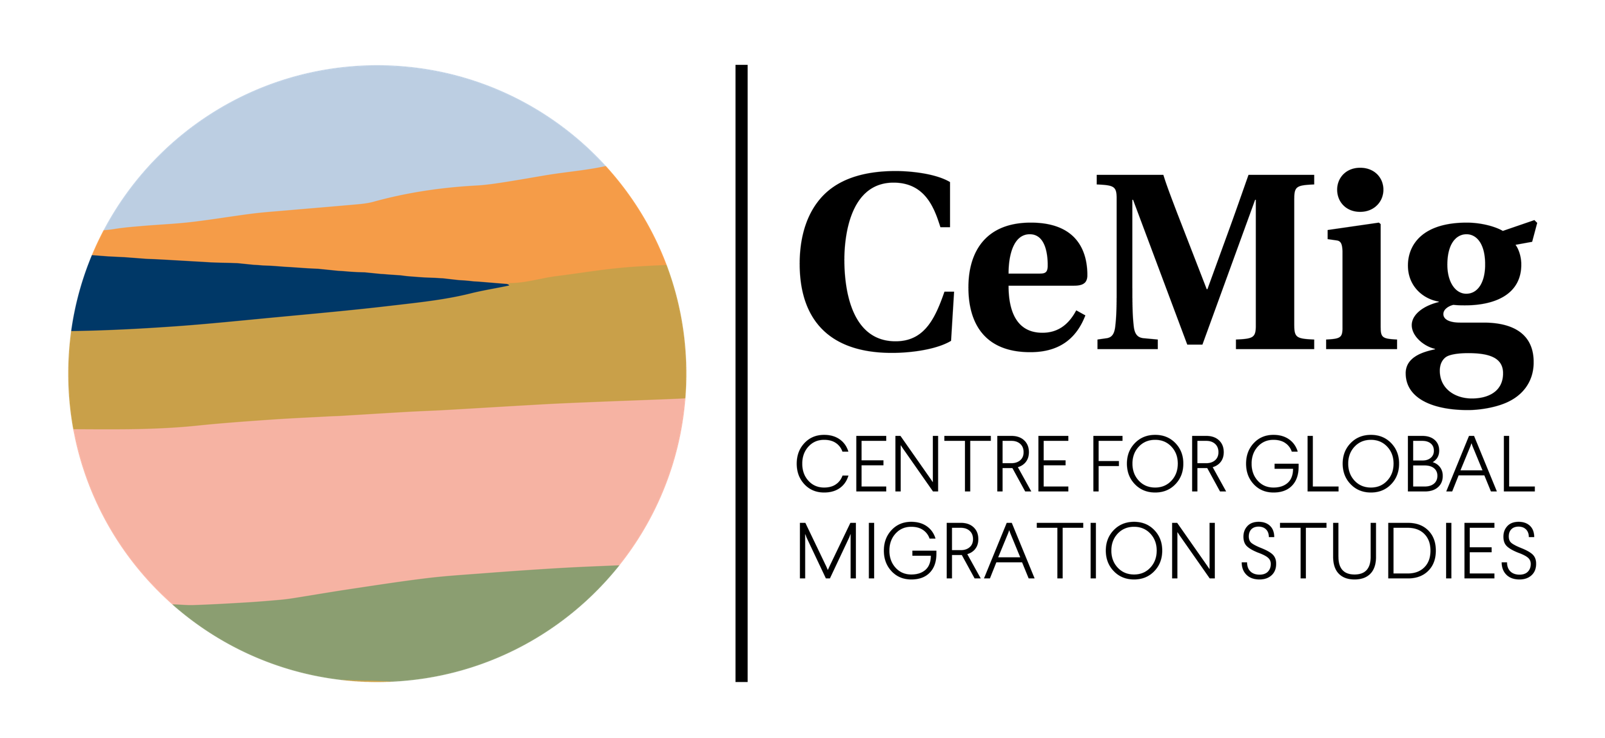

Please fill in the application form, sign it and send it by post or email (scan version) to:

Georg-August-Universität Göttingen
Centre for Global Migration Studies (CeMig)
Attn: Dr. Jelka Günther
Heinrich-Düker-Weg 14, 37073 Göttingen
cemig@uni-goettingen.de

The CeMig board of directors decides about the acceptance as a second member. The applicant and the dean's office of the Faculty of Philosophy will be informed as soon as a decision on the application has been made.

Application for second membership/ affiliation at the
Centre for Global Migration Studies (CeMig) for members of the
University of Göttingen

I hereby apply for second membership or affiliation to the Centre for Global Migration Studies (CeMig).

- Personal data

Surname, First name:

Status group at the University of Göttingen:
☐ University professors (= application for second membership)
☐ Research fellows (“wiss. Mitarbeiter*innen”)(= application for second membership)
☐ Staff (“Mitarbeiter*innen in Technik und Verwaltung”) (= application for second membership)
☐ Doctoral students who are not research fellows (= application for affiliation*)
☐ Students
*Unlike second members, CeMig affiliates are not entitled to vote.

Information about the first membership in a faculty/institution of the University of Göttingen or information about the institutional affiliation:

- Faculty:
- Institution or chair:

Email address:

- Justification for the second membership or affiliation

Please state here your research and teaching priorities in the field of migration research and/or your other references to migration research.

- Information for the membership-database
☐ With this application, I agree to provide CeMig with information on my research and teaching activities relevant to CeMig and to update this information annually (or per semester) (see p.3).
I agree that this information may be stored in the membership data-base and made publicly accessible on the CeMig homepage.

Date, Place

Information for the CeMig membership database

Discipline:

Main areas of interest in the field of migration research:

Research region(s):

Courses in the coming semesters in the field of migration research:

Ongoing research projects in the field of migration research:

Link to own profile on the homepage of the University of Göttingen:

